Our Lady Immaculate Catholic Academies Trust
St Thomas More Catholic Primary School
Northampton Road, Kettering NN15 7JZ
Tel. 01536 512112

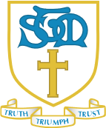
St. Thomas More Catholic Primary School – Governors Attendance record 2022-2023
 | 05.10.2022 | 07.12.2022 | 01.02.2023 | 22.03.2023 | 17.05.2023
Sophie Howes
Crofton Alexander
Martin Flannigan
Andrew Tunn |  |  |  | Apologies
Nicola Grove |  |  | Apologies
Ryan Plummer |  |  |  | Apologies
Alex Ridley | Apologies | Apologies

