
Summer Term One
I hope this letter finds you healthy and happy. We certainly are in very strange times and we are missing you all very much. Due to the increased time where we are accessing technology, please find below information that you might find useful. Remember, technology can be amazing to support our learning, to help stay in contact with others and to provide us with entertainment, but it needs to be used safely and responsibly.

Stay safe,
Mrs Howes



Netflix

What is live streaming?
Live streaming is when somebody broadcasts live (real time) video through an app or website. For example, users can live stream on Instagram, Twitch or Facebook. Children also post prerecorded videos and share them through apps such as YouTube or share them to friends via apps such as WhatsApp. Whilst live streaming, other users can comment, react and chat. Most of these apps are for those aged over 13+.

How can I help keep my child safe?
Use apps/websites together so you can work out how the privacy settings work and how to report or block other users when necessary. Ensure your child understands that they should talk to you or another trusted adult if they see anything upsetting online. Talk to your child about how to deal with peer pressure and how they shouldn’t share or participate in anything that makes them feel uncomfortable.

https://www.nspcc.org.uk/keeping-children-safe/online-
safety/livestreaming-online-video-apps/

Digital Wellbeing

We all need to be aware of how being online can affect us and look after our digital wellbeing. Childnet have further information about what digital wellbeing is as well as how you can support your child’s digital wellbeing tailored to their age:

https://www.childnet.com/parents-and-carers/hot-topics/digital-wellbeing

Screen time

Due to the increased amount of time using technology to support learning, you might be worried about how to manage this. Internet Matters have produced these great guides which include the benefits and challenges of screen use as well as top tips for managing your child’s screen time based on their age.
https://www.internetmatters.org/issues/screen-time/

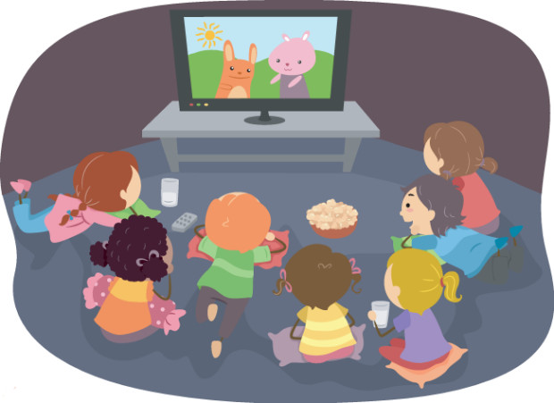



Video Calling

There are lots of different apps available to video chat with others – something a lot of us may be doing more of at the moment. This helpful article from Internet Matters outlines how to use some of the more popular platforms as well as some tips on how to use them safely including setting boundaries on when and where children can use these apps to chat with others.

https://www.internetmatters.org/blog/2020/04/09/how-to-use-video-chat-platforms-to-group-chat-with-family-and-friends/

We look forward to sharing these experiences with your child and continuing to watch them grow! If you have any questions, please do not hesitate to come in and see us.
The Reception Team

