**Rainbow Room**

Do you have a worry?

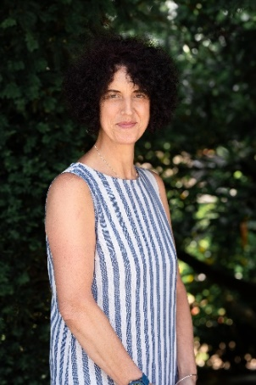

When it rains, look for rainbows and Mrs Stanyon.

Head to the Rainbow Room.

Try not to worry.

Check your Helping Hand.