
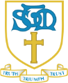
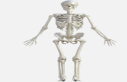
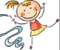
St. Thomas More Catholic Primary School
Autumn Term 1 Curriculum Newsletter – Year 3 A message from Mrs Grove and Mrs MacFarlane
Welcome back! We hope that you have all had a good rest over the Summer term and are looking forward to a busy term ahead in Year 3! We have lots of exciting things coming up this term, linked to our new topic ‘Under The Sea’ and we can’t wait to get started. Mrs Burn, is in Year 3 to help and support us, we are looking forward to getting to know you all. If you have any questions with regards to school, please do not hesitate to come and see us! Our door is always open.
Homework
We would expect the children to read at home five times per week. Please ask your children a range of questions about the book to ensure they have fully understood it. For example, questions where they can find the answer (eg. Where did X go after they had been shopping?) and also questions that require the children to form their own opinions (eg. Who was your favourite character and why?) Please ensure that your child fills in their reading record book and it is signed. Reading books will be changed on Friday. Children need to learn their times tables and will be starting with their 3 times tables. Your child will be tested on a Friday. Also, the children will be given their CGP homework books on a Friday and need to be returned the following Friday marked. We will be post on class dojo on a Friday to say what pages need completing.
  RE  Creation and Covenant  In year 3 we are starting to use a new scheme for religion. In the first half term, we will be looking at the first story of Creation from the book of Genesis in more depth. Creation as God’s gift.  Prophecy and Promise  Mass. The Gospel of Matthew and the Nativity.  Diversity  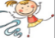  The Mandir  PE  Children will have PE on a Friday and need to wear their PE kit to school. As we approach the cold weather, please can you ensure that the children have tracksuit bottoms, or something like that and their school sweatshirt. They will also need to wear trainers. Also, please ensure that if your child wears earrings, or any jewellery, that they are removed before they coming to school. If your child has just had them pierced, or if there is a problem, please speak to us. | Creative Curriculum  Our topic is ‘Under the sea’ We will be exploring lots of exciting things.  We will answer questions like:  - Where does the water cycle take place?  - Compare and contrast the physical process of the water cycle with any other two physical geographical processes.  - Identify that animals, including humans, need the right types and amount of nutrition.  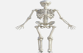    - Identify that humans and some other animals have skeletons and muscles for support, protection and movement.  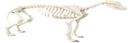  .  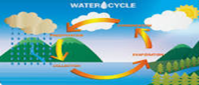
English  We will be using the film ‘Shark Tale’ as a stimulus for our writing    - Daily grammar, punctuation and spelling.  - Narrative  - Instructions  - Oracy to writing  - Poetry - Clerihews | 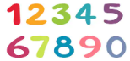  Maths  - Place value  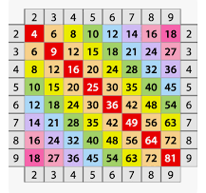  - Addition and subtraction  - Multiplication and division  - x3, and x4 times tables.

