Year 3 – Autumn term topic homework
Under the sea’
For our topic homework this term, the children are invited to get imaginative and artistic by creating

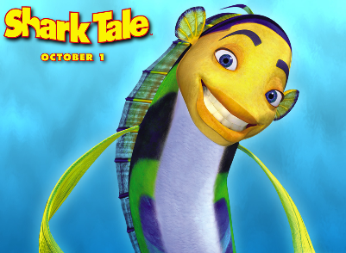
Choose a specific area of the sea that you would like to re-create.
You could use:
- Decorative, recycled and found materials;
- Old photographs;
- Drawing materials;
- Natural materials such as shells, seaweed, pebbles and sand;
- Small fish or related objects;
- Any other things you like!

Here are a few photographs to inspire you; there are many more online.
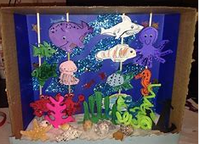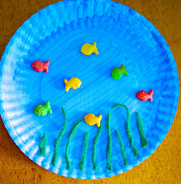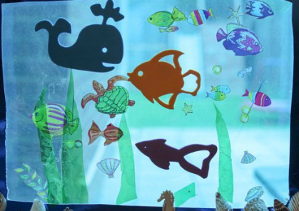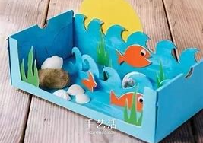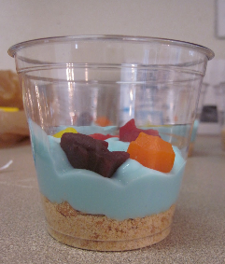

This task can be completed at any time during the Autumn term; please come and see Mrs. Grove if you have any questions. I look forward to sharing these projects together.

