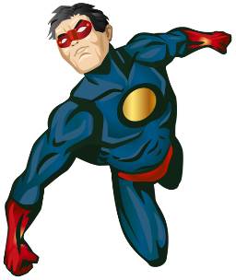
Year 2– Autumn term topic homework ‘Lights, Camera, Action!’

Superheroes

For our topic homework this term, the children are invited to get imaginative and creative by making their own superhero shield.

Below is an example of how to make a simple shield.
You can however be as creative as you want.
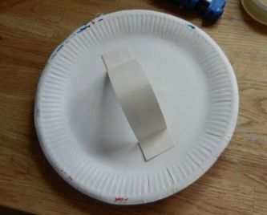

To make a simple shield you can use:
- Paper plate
- A piece of card for the handle (or a cut up paper plate)
- Coloured pens/paint

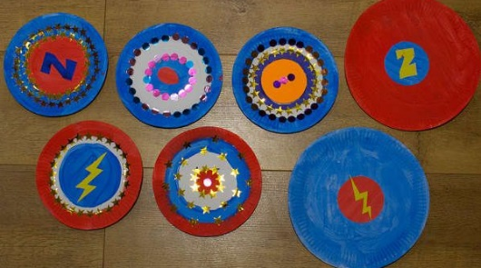
A YouTube tutorial can be found here- https://www.youtube.com/watch?v=YMyMvR96Ouw

The most important thing is to have fun!

