St. Thomas More Catholic Primary School


Autumn Term Curriculum Newsletter: Year 2
A message from Mr McDonald
Welcome back! I hope that you all had a lovely break.
I have already been extremely impressed with the children’s work ethic and positive attitudes to learning.
We have lots of exciting work to complete over the next few weeks and I am sure that the children will enjoy telling you all about our fun, new topic.
Below is an outline of what Year 2 will be up to this half term. If you have any questions please don’t hesitate to ask me!
Mr McDonald
Mathematics

- Daily arithmetic and times tables (x2, x5, x10)
Number:
- Place value, including reading/writing numbers to 100 in numerals/words and recognising the place value of each digit in a 2-digit number.
- Addition and subtraction, including using addition/subtraction facts up to 20.
- Multiplication and division
- Money
English

- Superhero stories (Traction Man / Supertato)
- Newspaper writing
- Toy advert
- Daily reading (reading)
- Grammar: working on national requirements
- Spelling and handwriting practise

Religious Education
Branch 1 – Creation and Covenant
Noah the sacrament of baptism

Branch 2 – Prophecy and Promise
The Nativity. The Visitation. Magnificat and Advent.

Diversity Week
Prayer at home - Puja

Creative Curriculum – Superheroes

- Creating superhero secret identities
- Jesus, superhero – music and performance.
- Real life superheroes: Florence Nightingale and Mary Seacole
- My own super self! Amazing bodies, healthy lifestyles and life cycles.
- Portraits
- Who are our superheroes?
- Magical mapping
- Animals and Humans- Science

Homework and how to help your child at home…
- Regular reading is essential to support your child’s learning across the curriculum. Please try to listen to your child read as often as you can and record it in their reading record.
- In Year 2 we learn x2, x5 and x10 multiplication tables; please help your child to practise these at home.
- Homework from the CGP books will be set every Friday, with the due date being the following Friday.


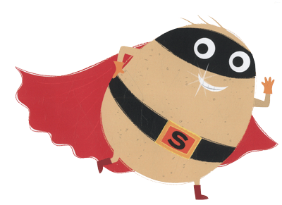

Diary dates and other useful information…
- On Wednesday morning’s, the class will be having Outdoor learning sessions with Mrs Grove.
- PE is on Thursday’s so your child can come to school in their PE kit on this day.
- The children can change their reading book every Friday.

