

Monitoring and Filtering at St. Thomas More Catholic Primary School 2025/26

At St. Thomas More, EasiPC provides us with a range of focused support to ensure that we can confidently and safely use technology within our school to educate our children.
As part of this service, EasiPC provide us with Exa Education’s effective filtering and monitoring through a product called SurfProtect®, which is EXA´s own in-house developed, state of the art, content filtering system.
Why SurfProtect?
Developed in-house, SurfProtect® is one of the UK’s most trusted web filters. Designed specifically for the education sector, SurfProtect® offers affordable protection that keeps students safe online without impacting their learning experience.
Updated DfE KCSiE Guidelines
Both SurfProtect® (Quantum & Quantum+, our in-house content filtering solutions) products fulfil the filtering requirement set out in the Department for Education’s Keeping Children Safe in Education (KCSiE) guidelines.
What does our content filtering system do to comply with these updates?
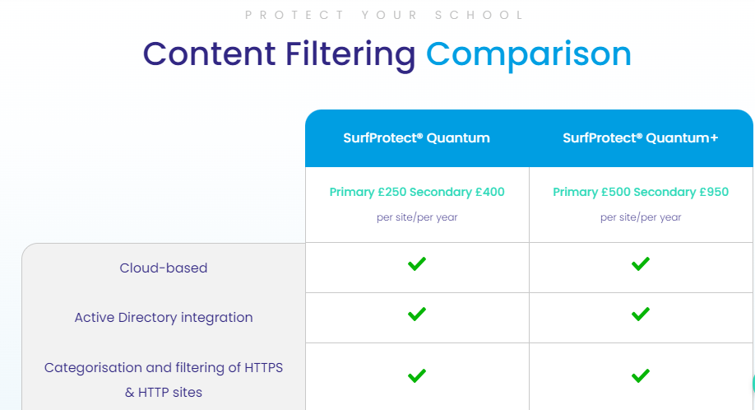
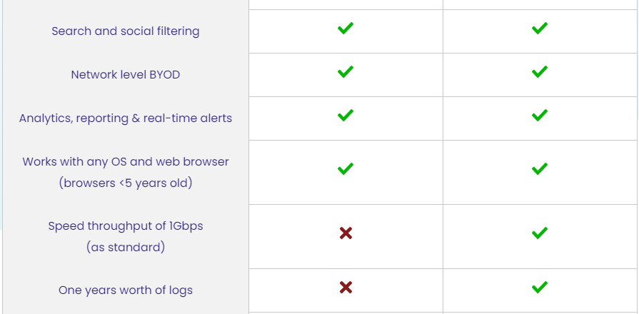
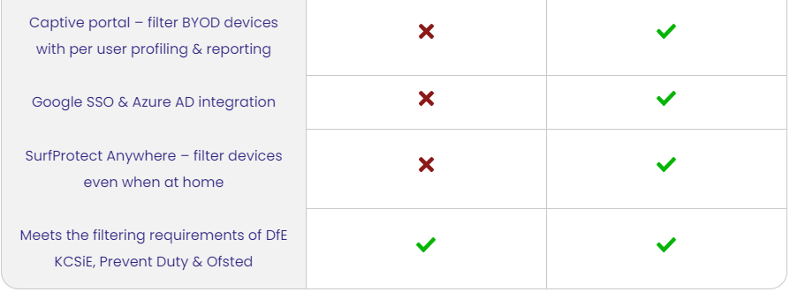

Our Monitoring Systems
At St. Thomas More, we monitor both staff and pupil’s use of technology and website access.
When a pupil or member of staff attempts to access a website (including through generative AI) , which has been filtered by SurfProtect, an email notification from ‘Securly’ is instantly sent to Mrs. Howes (Head Teacher) and Mr. Tunn (Online Safety Lead) which identifies:
- the website which was blocked
- the date and time the search was made
- the individual email account that made the attempted search
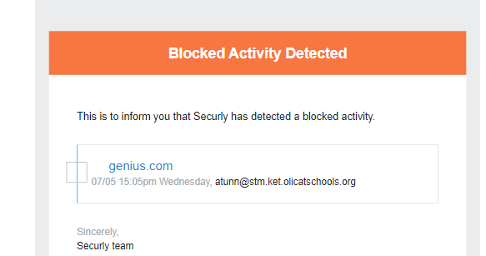

Following this notification, Mr. Tunn (Online Safety Lead) promptly investigates the attempted search by speaking to the adult or child who made the search and address in line with school policy.
This is a similar process for when a member of SLT attempts to access a blocked website, however the alert email is sent to Mrs. Howes. If Mrs. Howes attempts to access a blocked website, the notification is sent to the Trust.

Reporting on Monitoring and Filtering at St. Thomas More
In order to report and keep record of any attempted searches in school by staff and children, which are blocked, Mr. Tunn (Online Safety Lead) logs these on our ‘Online Monitoring’ forms – one for staff and another for children. This logs all relevant details of the search and any actions to come as a result.
Date | Staff | Real Time Alert | Action Taken | Next Steps

‘School-appropriate’ blocked websites
Due to the importance of filtering inappropriate content for our children and staff in school, occasionally some websites, which are suitable to use in school with children to enhance the teaching and learning of a lesson, are blocked.
In the event of this, staff can complete a ‘Website Access Request Form’ which are kept in the staff room.
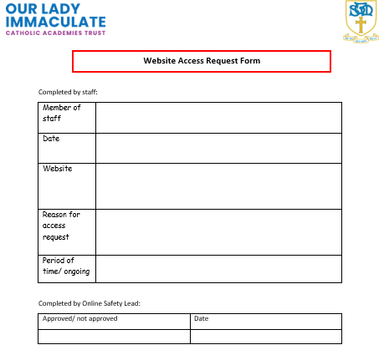
Mr. Tunn (Online Safety Lead) will then review the request and liaise with our onsite EasiPC technician to grant access, if suitable.

