Year 4 – Spring term topic homework A Step Back in Time!

The Vikings

For our topic homework this term, the children are invited to get imaginative and artistic by creating their own Viking Longboat art!
You could use:
- Decorative, recycled and found materials;
- Drawing materials;
- Paints!
- Any other things you like!

Here are a few photographs to inspire you; there are many more online, you can even make your art 3D and come out of the background!
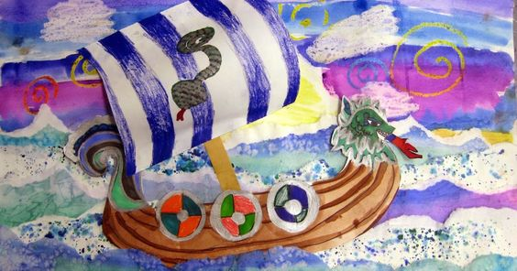
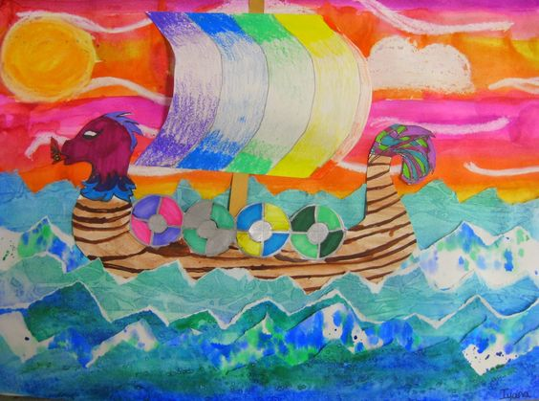
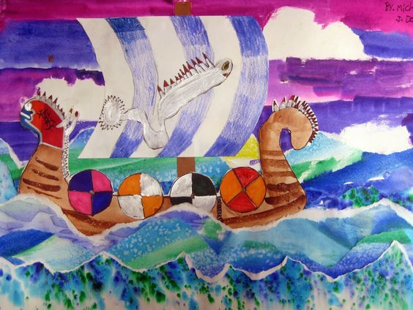

This task can be completed at any time during the Spring term; please come and see Mr Tunn or Miss Giddings if you have any questions. All homework will be displayed in the classroom. We can’t wait to see your creations!

