St. Thomas More Catholic Primary School
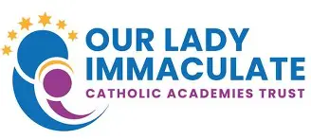

Spring Term Curriculum Newsletter: Year 2
A message from Mr McDonald
Hi everyone. We have another very exciting term ahead of us and this document outlines what the children will be learning in the weeks and months ahead.
This week, the school will be starting our new whole school topic focus ‘A Step Back in Time’. The Year 2 focus this term will be ‘The Great Fire of London.’ We have lots of very exciting lessons planned and look forward to seeing all of the amazing work that comes from it.
If you have any questions about the work please don’t hesitate to contact me.
Mr McDonald
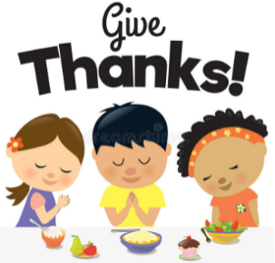
Religious Education

Galilee to Jerusalem
Baptism; John the Baptist; miracle; parable; temptation; sin; sorrow; forgiveness; reconciliation.

Desert to Garden
Baptism; John the Baptist; miracle;
parable; temptation; sin; sorrow;
forgiveness; reconciliation.

Creative Curriculum – Fire, fire!
History- The Great Fire of London
Art- landscapes
DT- model houses
Computing - Programming – Robot Algorithms
Science- Materials, Plants
Geography- Mapping the World and
Continents & Oceans
Music- ‘I wanna play in a rock band’
PE- Team building, sending and
receiving
Homework and how to help your child at home…
- Regular reading is essential to support your child’s learning across the curriculum. Please hear your child read at least three times a week and make a note in their reading record book.
- Reading books will be changed every Friday.
- In Year 2 we learn x2, x5 and x10 multiplication tables; please help your child to practise these at home.
- The teacher will inform you via Dojo of which CGP pages the children need to complete each week.
- Any extra work completed through the “Google Drive” resources will be hugely beneficial.

Diary dates and other useful information…
- Mrs Grove will teach the class on a Wednesday morning, including forest school.
- PE is every Wednesday. Please can the children come to school in their PE kit.

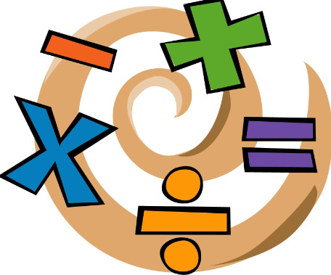
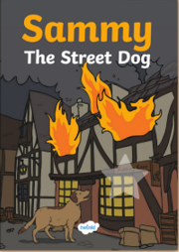
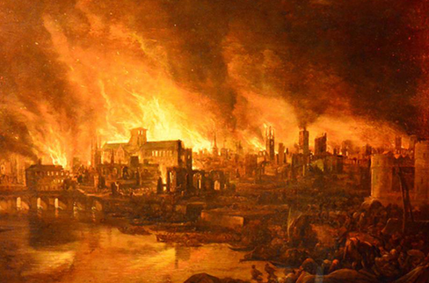
English

- Fiction and non-fiction writing.
- GPS-Subordination, adjectives, adverbs, verbs and nouns. Past and present tense
- Daily handwriting and spelling

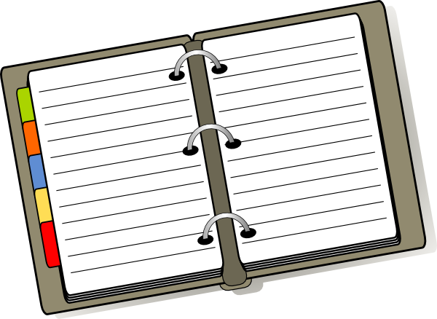

Mathematics

- Daily arithmetic
- Times tables (x2, x5, x10)
- Money – counting money, comparing amounts, finding change and finding the difference.
- Multiplication and division

