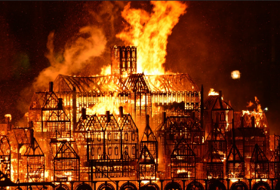
Year 2– Spring term topic homework ‘A Step Back In Time’

The Great Fire of London

For our topic homework this term, the children are invited to get imaginative and creative by making their own Tudor house.

Use any medium that you wish to create your 3D model.

Here are a few photographs to give you some ideas:
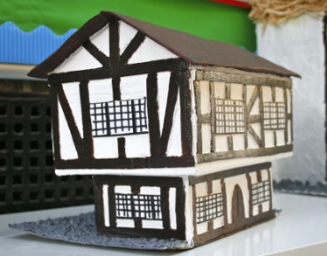
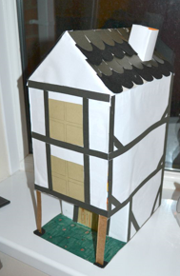
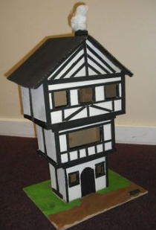
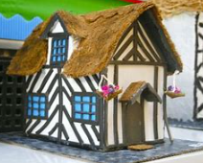

The most important thing is to have fun!

This task can be completed at any time during the spring term; please come and see us if you have any questions. We look forward to seeing your creations.

