Year 3 – Spring term topic homework ‘Step back in time!’
Stone Age

For our topic homework this term, the children are invited to get imaginative and artistic by creating their own Stonehenge or Stone Age village scene. If they would prefer to complete some research, they can discover what kind of animals lived in the Stone Age and present it anyway they like.
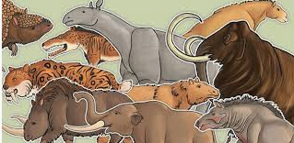
You could use:
- Decorative, recycled and found materials.
- Old photographs.
- Drawing materials.
- Clay, plasticine, wood, and straw
- Any other things you like!
Here are a few photographs to inspire you; there are many more online.
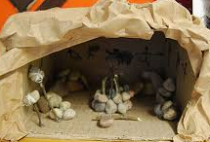
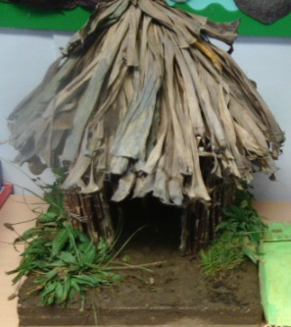
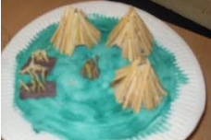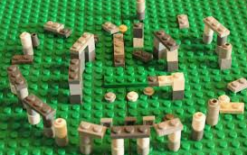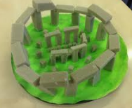
This task can be completed at any time during the spring term; please come and see Mrs. Grove or Mrs MacFarlane if you have any questions. I look forward to sharing these projects together.

