
A message from Mrs Grove and Mrs MacFarlane…
Welcome back! I hope that you and your family have had a restful Christmas together and that the children are raring to go for the New Year! Our topic for this Spring term is called ‘Step back in time’. Our learning will be themed around the Stone Age. If you have any questions with regards to school, your child’s progress, or homework, please email, call the school office to make an appointment or come and see us.
How to help your child at home…
We would expect the children to read at home every day and their reading record book to be signed. Please ask your children a range of questions about the book to ensure they have fully understood it. For example, questions where they can find the answer (eg. Where did X go after they had been shopping?) and questions that require the children to form their own opinions (eg. Who was your favourite character and why?)
It is very important that the children learn and are fluent with their times tables. In year 3, children are expected to know their twos, fives, tens, threes, fours, and eights, out of order and corresponding division facts. Please help them by testing randomly and regularly. Homework will be sent home on a Friday and need to be returned by the following Friday. Please can this be marked, thank you.
RE – Spring  ‘Galilee to Jerusalem’ - Children will encounter the Gospel of St Matthew. Matthew’s gospel is divided into seven books. We will look at the miracles and parables according to Mathew  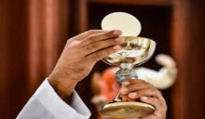  ‘Desert to Garden’ - Children will explore the meaning of the Eucharist  PE  PE will remain on Friday’s and sometimes we will be outside, so please ensure that your child has warm clothes. Also, please ensure that if your child wears earrings, or any jewellery, that they are removed before they come to school. If your child has just had them pierced, or there is a problem please speak to me and we will find a solution. | Creative Curriculum  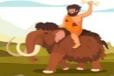  Our topic is ‘Step back in time’ We will be exploring lots of exciting things.  We will be learning about:  Describe the clothes, way of life and actions of people in the past.  Use evidence to describe the culture and leisure activities from the past.  Use evidence to describe buildings and their uses of people from the past.  Ask questions and find answers about the past.  Science – Plants  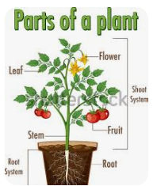  We will be learning about:  What plants need to grow  Identify the different parts of a plant  Why are plants important  Pollination and seed spreading
English  Daily grammar, punctuation, and spelling.  Narrative, linked to the ‘’The wild way home’ by Sophie Kirtley  Planning and editing writing.  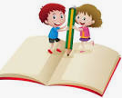  Explanation text  Diary writing  Free verse poetry | Maths  Number: multiplication and division  Length and perimeter  Fractions  Mass and capacity  Recall and use facts from x3, x4 and x8 tables  Solve problems including missing number problems involving x and÷, positive integer scaling problems and correspondence problems.

