Year 3 – Summer term topic homework ‘Colourful Cultures’
Ancient Egypt
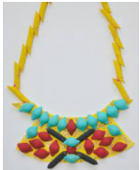
For our topic homework this term, the children are invited to get imaginative and artistic by creating their own Egyptian jewellery or an Egyptian headdress. If they would prefer to complete some research, they can discover all about the Egyptian gods. They can present their findings anyway they like, form posters to PowerPoints.
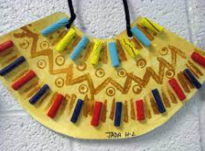
You could use:
- Decorative, recycled and found materials;
- Drawing materials
- Dried pasta
- Clay, plasticine, wood and straw
- Any other things you like!
Here are a few photographs to inspire you; there are many more online.
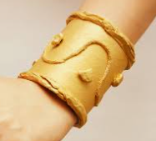
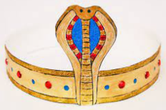
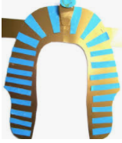
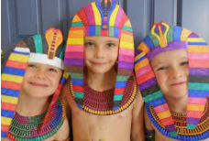

This task can be completed at any time during the summer term; please come and see Mrs. Grove and Mrs MacFarlane if you have any questions. We look forward to sharing these projects together.

