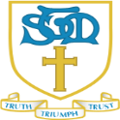

St. Thomas More Catholic Primary School
Summer Term Curriculum Newsletter – Year 3
A message from Mrs Grove, Mrs MacFarlane and Mrs Burn…
Welcome back! We hope that you have all had a good rest over the Easter holidays and not consumed too many eggs!
Our whole school topic for the summer term is called ‘Colourful Cultures’. Our class topic is ‘Ancient Egypt’ and we will be learning and locating where Egypt is, why the River Nile was so important to the Egyptians, family life, the mystery surrounding Tutankhamun and Egyptian gods. Mrs Burn and I are looking forward to this topic and have lots of fun activities for us to do.
How to help your child at home…
I would expect the children to read at home every day and please remember to fill in and sign their reading record book. Ask your children a range of questions about the book to ensure they have fully understood it. For example, questions where they can find the answer (eg. Where was X going to next?) and also questions that require the children to form their own opinions (eg. What was your favourite part of the story and why?) Friday is book changing day, please could you ensure that your child has been reading daily and their reading record book signed. Children need to be fluent with their times tables. They are expected to know their twos, fives, tens, threes, fours, and eights. Please help them by testing randomly and regularly, they will be tested on a Friday
RE  Topics that will be taught in summer term.  Sikhism - Sacred Texts and Worship  To the Ends of the Earth - Mass and mission.  Dialogue and encounter - Passover. Islam – One God creator. | Creative Curriculum  Our topic is ‘Colourful Cultures’ We will be exploring lots of exciting things. As historian’s we will be learning about:  - Locating Egypt on a map.  - Why the River Nile was so important.  - Mummification.  - Egyptian gods.  - The life of Tutankhamun  - Designing and making ‘Nekhbet’ Egyptian pendants.  - Sketching Egyptian gods.  - Observational drawings of Egyptian artefacts  - Research food eaten in Egyptian times  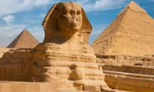  - Making a death mask  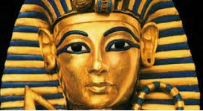
PE
On a Wednesday morning, the children will be having PE, so they need to continue to come to school in their PE kit. Also, during the summer term we will going outside more so please ensure that your child has suitable footwear. Also, please ensure that if your child wears earrings, or any jewellery, that they are removed before they come to school. If your child has just had them pierced, or there is a problem please speak to me and we will find a solution.
  English  - Grammar and punctuation  - Recount  - Creative writing  - Newspaper report.  - Descriptive writing based on the animated film Tadeo Jones | 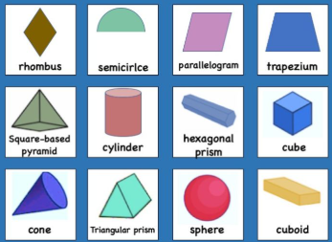  Maths  - Money  - Time  - Shape  - Statistics  We are continuing with our times tables and by the end of year 3 the children should know 2, 3, 4, 5, 8 and 10’s. The children need to know the division facts also.

